Trauma-Informed Workplace
Patrick Henry Family Services
Trauma-Informed Care Proficiency Training

The requirement for this unit of training is to complete three (3) modules of an online, interactive, training program. We have borrowed this training program from the Alberta Health Services (Alberta, Canada).
Note: Because this material was produced in Canada, many of the statistics quoted are about Canada. However, the percentages are very similar to the U.S.

Of the six modules in the program, you are required to complete module 1 (What is Trauma Informed Care?) and module 6 (Emotional Literacy). Then you are to select one of the other four modules to complete. (You may do more than one of the electives but the requirement is at least one.)
Here is the link:

  - https://www.albertahealthservices.ca/info/Page15526.aspx

In the center of the webpage you will see the following box.

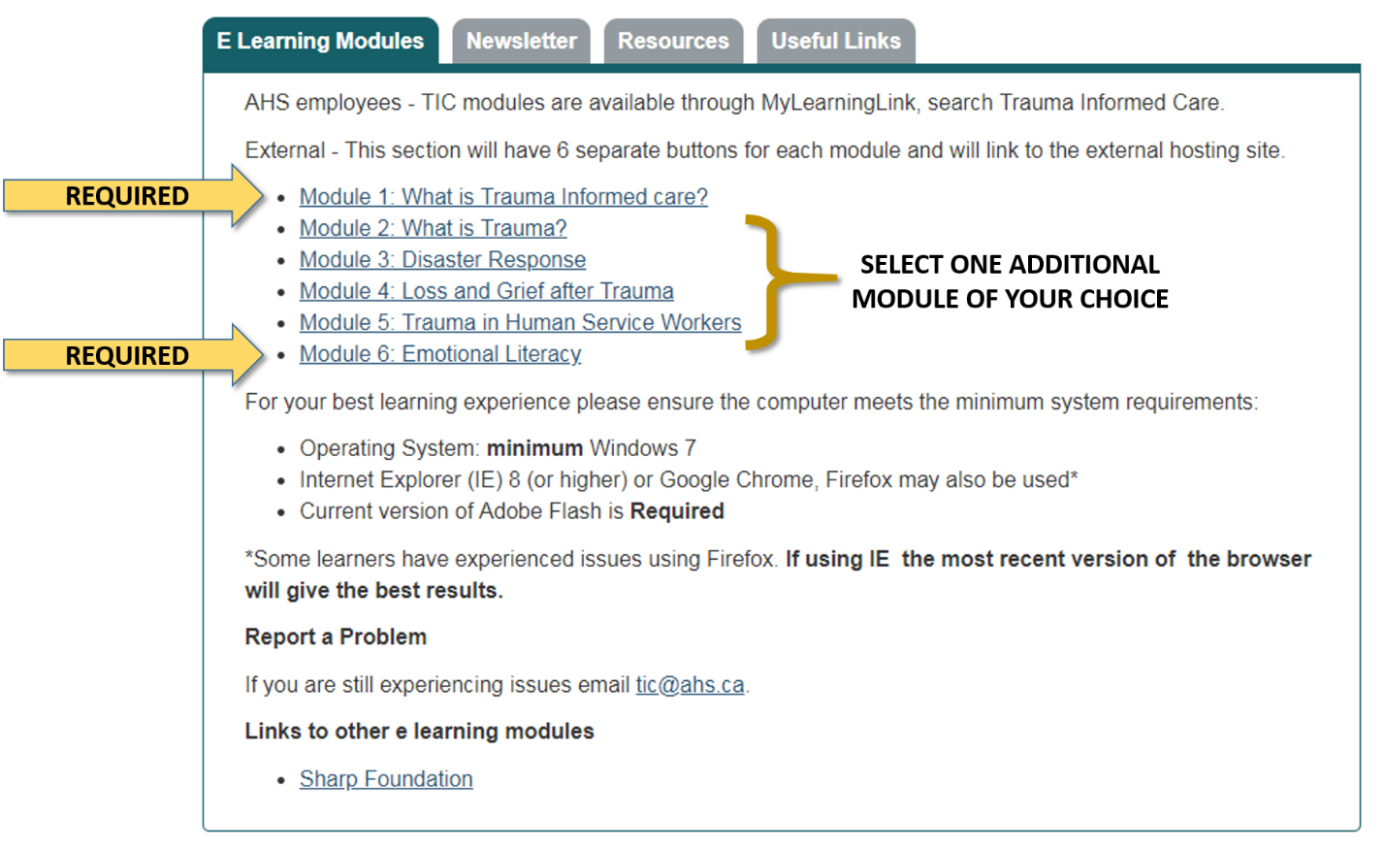

When you complete each module, make sure you print the certificate of completion that is made available. Give copies of your certificates of completion to your supervisor to receive credit for completing this unit of your Trauma-Informed Care Proficiency Training plan.

If you have questions, contact Jim Herron – jherron@patrickhenry.org or extension 503

